MINI PROJECT
ML-DA-DAF 69
ANNIE ALBERT
Power BI

Open Power BI
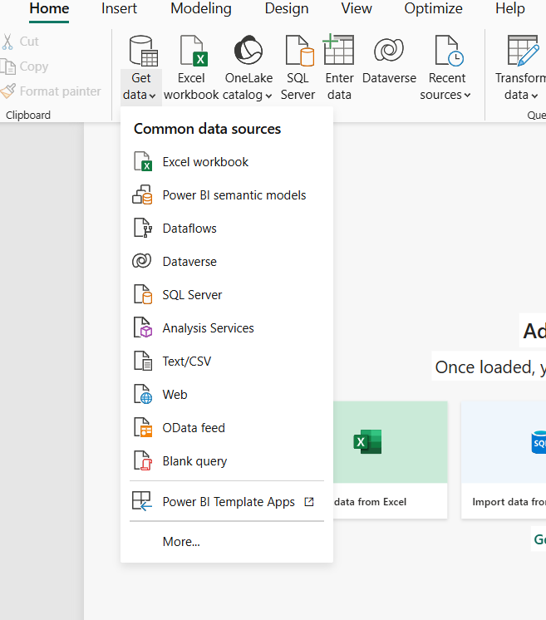
Go to excel workbook-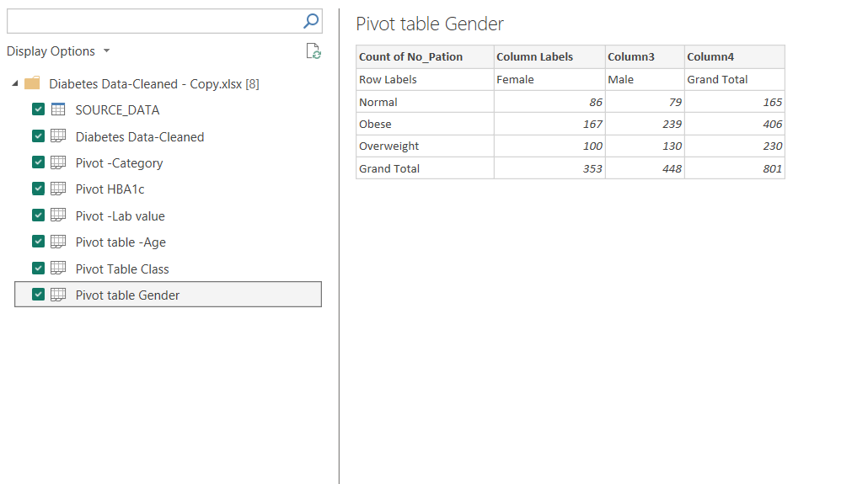load
Create measures
Go to modelling view- New measure
1.Total Patients = COUNTROWS('SOURCE_DATA')
2. Avg HbA1c = AVERAGE('SOURCE_DATA'[HbA1c])
3. Avg BMI = AVERAGE('SOURCE_DATA'[BMI])
Avrg Cholesterol = AVERAGE('SOURCE_DATA'[Cholestrol ])
Avg LDL = AVERAGE('SOURCE_DATA'[LDL])
Avg HDL = AVERAGE('SOURCE_DATA'[HDL])
Avg TG = AVERAGE('SOURCE_DATA'[TG])
Avg Creatinine = AVERAGE('SOURCE_DATA'[Creatinine])
Avg UREA = AVERAGE('SOURCE_DATA'[UREA])
Avg VLDL = AVERAGE('SOURCE_DATA'[VLDL])

Go to report view to create card
Create card using total patient, Avrg BMI, Avrg HbA1c by dragging
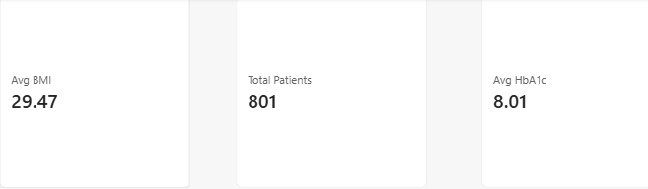
Insert Charts and slicers from Visualization tab
Final output
